20170323
# It making same way as regular udp input.
# But only copy file config for tcp input.

cp /etc/keepalived/conf.d/tcp-1254{5,6}-input.conf

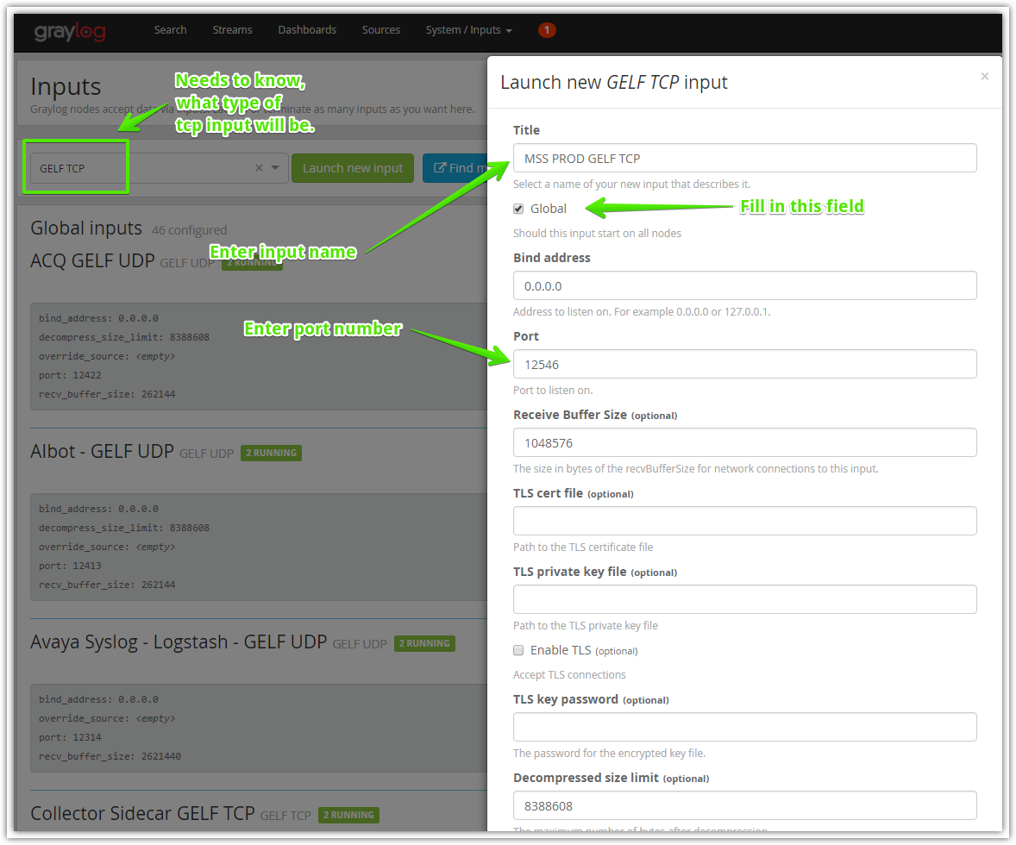

# Other fields are need not fill in.
